Computer Shop System

Use-Case Specification: Update Order

Version 1.0

Revision History

|  |  |  |  |
| --- | --- | --- | --- |
| **Date** | **Version** | **Description** | **Author** |
| 5/12/2019 | 1.0 | None | Pham Thi Hong Trang |
|  |  |  |  |
|  |  |  |  |
|  |  |  |  |

Table of Contents

1. Use-Case Name 3

1.1 Brief Description 3

2. Flow of Events 3

2.1 Basic Flow 3

2.2 Alternative Flows 3

2.2.1 < First Alternative Flow > 3

2.2.2 < Second Alternative Flow > 3

3. Special Requirements 3

3.1 < First Special Requirement > 3

4. Preconditions 3

4.1 < Precondition One > 3

5. Postconditions 3

5.1 < Postcondition One > 3

6. Extension Points 3

6.1 <Name of Extension Point> 3

Use-Case Specification: View News

# Use-Case Name

## Brief Description

# This use case defines how admin update orders of customers after adding computer to shopping cart and fill order’s information.

# Flow of Events

## Basic Flow

When customer who already logged in computer shop system add a computer to shopping card, customer will fill all information for delivery. But in generally, they can be filled some wrong information. When shop’s staff have some contacts to confirm about this order, staff will check all information of this order. If this order has some errors, admin will update it.

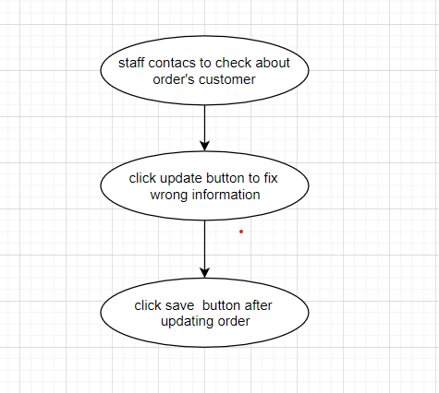

# Special Requirements

## < None Special Requirement >

# Preconditions

Customer go to the website, already added computer to shopping card and creat order.

# Post conditions

## Shop computer makes sure about order’s information.

# Extension Points

No extension points.